# Technical Career Education Private Limited

5th floor, Sahyadri Campus, Adyar, Mangalore 575007



**Innoventure Internship**

**PROJECT REPORT**

# 2022 - 23 Project Title: Street Adda Food Delivery

Submitted by:

|  |  |
| --- | --- |
| Abhilash RB | 4SF22CS400 |
| Aneesh Shetty | 4SF21CY402 |
| Jithesh | 4SF22CY403 |
| Nithish | 4SF22CY406 |
|  |  |

Institution:



**Sahyadri College of Engineering and Management**

Adyar Mangalore 575007

# CONTENTS

**Project Overview**

1. **Introduction**

1. **Problem Statement**

1. **Solution**

1. **Conclusion/Outcome:**

1. **Reference List**

# Project Overview

|  |  |  |  |  |
| --- | --- | --- | --- | --- |
| Problem Statement | Online food delivery application where users can search and order in the collection. | | | |
| Solution  Proposed *(video*  *Link)* | https://docs.google.com/document/d/1euvJzmPDbpJtaQF4X2ELX6TQ4eHLcsYZ/edit?usp=drive_link&ouid=103030693230895638541&rtpof=true&sd=true | | | |
| Link to the final Challenge presentation | https://docs.google.com/document/d/1euvJzmPDbpJtaQF4X2ELX6TQ4eHLcsYZ/edit?usp=drive_link&ouid=103030693230895638541&rtpof=true&sd=true | | | |
| Link to photos/ videos drive | https://docs.google.com/document/d/1euvJzmPDbpJtaQF4X2ELX6TQ4eHLcsYZ/edit?usp=drive_link&ouid=103030693230895638541&rtpof=true&sd=true | | | |
| Github Link | https://github.com/nithish-shettigar/final-project | | | |
| Team Name | D5 | | | |
| Team Members | Name | USN | Class/Section | College Internship  Report  ***(Reference***  ***format*** |
| Abhilash RB | 4SF22CS400 | 4ACS |  |
| Aneesh Shetty | 4SF22CY402 | 4CY |  |
| Jithesh | 4SF22CY403 | 4CY |  |
| Nithish | 4SF22CY406 | 4CY |  |

## 1. Introduction

Our goal is to create a web application that lets you manage and enjoy your personal food collection with ease. Using the MERN stack (MongoDB, Express.js, React, and Node.js), we're building a full-stack solution to make your Food-related tasks a breeze.

First things first, you can sign up and log in securely. Once you login you can be able to see the menu and the price and then you can able to order the food by clicking on it.

Our ultimate goal is to create an interface that's both functional and appealing. We want ensure you can effortlessly order food. As we put the finishing touches on the project, rest assured that we're providing you with a top class foods of every corner of the state.

## 2. Problem Statement

Online food ordering is the process of ordering food from a website. The product can either be

food that has been specially prepared for direct consumption (such as vegetables straight from a

farm or garden, frozen meats, etc.) or food that has not been (such as direct from a certified home-

kitchen, restaurant). The effort to create an online food ordering system aims to replace the manual

method of taking orders with a digital one. The ability to rapidly and correctly create order

summary reports whenever necessary is a key factor in the development of this project.

The potential of an online food ordering system is enormous. Any restaurant or fast-food chain can use this PHP project to keep track of customer orders. This project is simple, quick, and precise.

There is less disk space needed. Mongo DB Server is used as the backbone by the online food ordering system, eliminating the risk of data loss and ensuring data security. Customers have the option of either having the food delivered or picked up. A customer starts by selecting the

restaurant of their choice, then scans the menu, picks an item, and then decides whether they want

it delivered or picked up. Then, when picking up the food, you can pay with cash at the restaurant

or with a credit card or debit card using the app or website. The customer is informed by the

website and app about the food's quality, how long it takes to prepare, and when it will be ready

for pick-up or delivery.

.

## 2. Solution

Here's a list of the essential tools and technologies needed for each component of the MERN stack:

1. **MongoDB:**

• **MongoDB:** A NoSQL database for storing movie-related data.

1. **Express.js:**

• **Express.js:** A web application framework for Node.js that handles server- side logic and routing.

1. **React:** 
   * + - **React:** A JavaScript library for building user interfaces.
       - **React Router:** For managing client-side routing within the application.
2. **Node.js:** 
   * + **Node.js:** A JavaScript runtime environment that allows server-side scripting.

• **NPM (Node Package Manager):** To manage packages and dependencies.

**Additional Tools and Technologies:**

* + - **GitHub:** Hosting platform for code repositories and collaboration.
    - **Visual Studio Code (or any preferred code editor):** To write and edit code efficiently.
    - **Postman:** API testing tool for testing endpoints and data flow.

**2.2 Flowchart of the project :**

1. **User Registration and Authentication:** 
   * Users start by visiting the application's landing page.
   * New users can register by providing their details, including a username and password.
   * The registration information is securely stored in the MongoDB database.
   * Existing users can log in using their credentials.
2. **Food Display:**

* After logging in, users are directed to the home page, where the food collection will be displayed.
* The home page interface is built using React, creating a user-friendly and responsive experience.

**3. Responsive User Interface:**

* The React front-end ensures a responsive design that adapts to various screen sizes and devices.
* Whether users access the application on a desktop, tablet, or smartphone, the interface remains user-friendly and visually appealing.

**2.3 Frontend & Backend**

<https://github.com/nithish-shettigar/final-project>

1. **Conclusion/ Outcome :**

The proposed solution for the Street food Database project addresses the challenges associated with managing and organizing foods collections. By leveraging the power of the MERN stack (MongoDB, Express.js, React, and Node.js), the solution delivers a comprehensive, user-friendly, and efficient application that caters to the diverse needs of enthusiasts.

* 1. **Available Food Collection:**
  + The solution enables admins to add and delete food from the food cart with ease.
  1. **Search Food:**
  + Users can quickly search for food using keywords.
  + This improves the user experience by making it effortless to select the enormous collection of street food.

* 1. **User Authentication and Privacy:**
  + The solution ensures secure user registration and authentication processes.
  + JSON Web Tokens (JWTs) are used for user authentication, ensuring data privacy and authorized access to foods collections.
  + Users can confidently manage the food collections without concerns about unauthorized access.

1. **Responsive User Interface:**

* The solution's React-based user interface is designed to be responsive across devices.
* Users can interact with their food collections seamlessly on different platforms, including desktops, tablets, and smartphones.

**5. Integration of Technology:**

* MongoDB serves as the database, storing food collection data securely.
* Express.js handles the server-side logic and routes, while Node.js ensures smooth server operations.

### 5. References

Home Page :

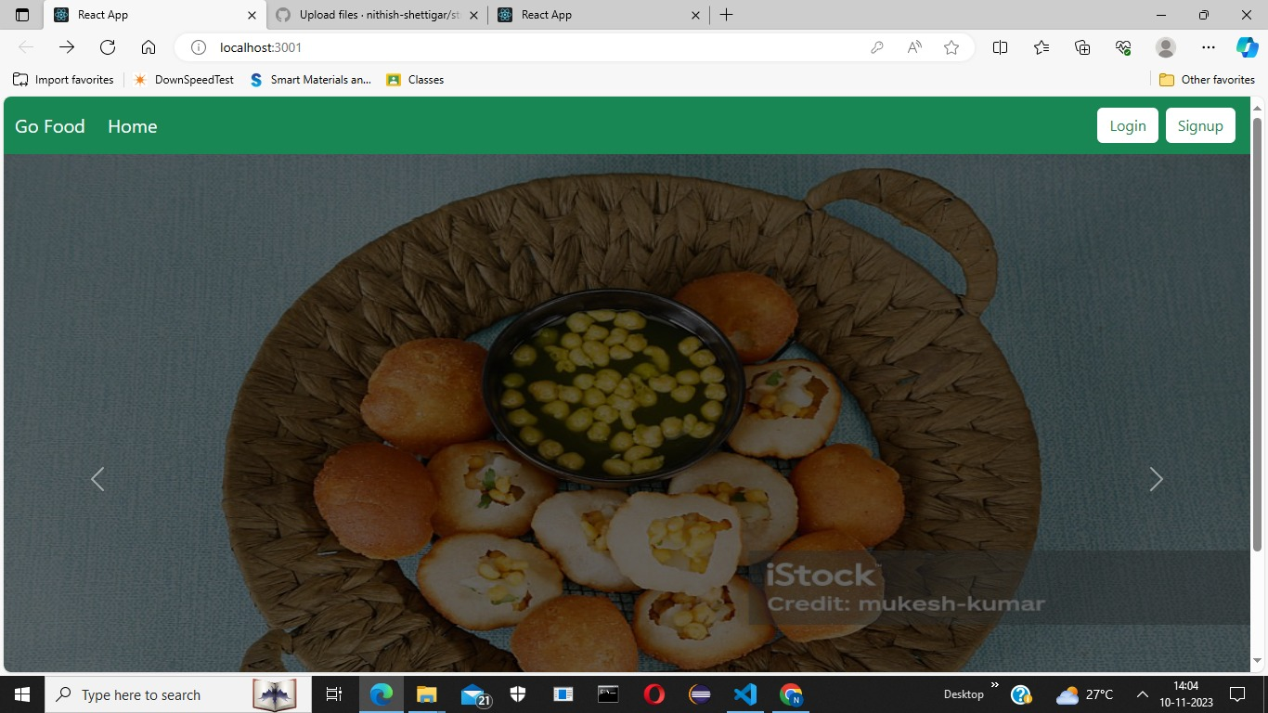

Sign in Page :

